Finding the Best Budget-Friendly Travel Destinations Using Data Mining
Final Project Report
Group 1
Hasmik Galstyan
Angela Johnson
Jeffrey Morales Toledo
Josue Sanchez
Annabel Tapia
Thant Thiri Myo Kyi
Course: COMP 541 — Data Mining
Instructor: Professor Taehyung Wang
Semester: Summer 2026
Submission Date: July 2026
California State University, Northridge

Table of Contents

Note: right-click the table above in Microsoft Word and choose “Update Field” to refresh page numbers.

Section 1 Business Understanding
This section covers the Business Understanding phase of the project, following the CRISP-DM 1.0 framework. It brings the content of our Project Proposal (submitted June 2, 2026) into this final report in a refined form.

1.1 Executive Summary
Travel planning is stressful. Travelers have to compare costs, ratings, weather, transportation, and activities across many places, and this information is spread across many different websites. Our project used data mining to help budget-conscious travelers, especially students and young adults, find destinations that are affordable but still worth visiting. We combined six public data sources (cost of living, world tourism statistics, Airbnb lodging prices, TripAdvisor hotel reviews, flight fares, and climate data) into one destination-level dataset of 4,999 global cities.
We then applied several data mining models. K-Means, Agglomerative, and DBSCAN clustering grouped the destinations into segments. A supervised airfare regression model filled in missing flight prices. A sentiment model (VADER, with a DistilBERT Transformer option) turned about 879,000 hotel reviews into a traveler satisfaction score. Finally, a Budget Value Index (BVI) combined cost, weather, and satisfaction into one ranking score. The result is a validated ranked list of 105 destinations, clear traveler segments, and an interactive dashboard. We measured success with clustering quality metrics (silhouette score and Davies-Bouldin index), cross-validated prediction error for the airfare model, and a sensitivity check on the ranking. This approach fits the problem well, because comparing destinations is really a multi-source integration and ranking problem, and that maps naturally to clustering, regression, text mining, and a composite score.

1.2 Project Background
For people traveling on a budget, the cheapest place is not always the best value. Some destinations are affordable but have fewer activities or lower ratings, while others cost more but offer a better overall experience. Cost, quality, and weather information sits on many separate websites, which makes a fair and fast comparison almost impossible. Travelers also weigh these factors differently depending on their budget and travel style.
The main stakeholders are budget travelers, mostly students and young adults departing from Los Angeles. Tourism boards and travel platforms could also benefit from data-driven destination discovery. The project was carried out as the Group 1 course project for COMP 541 Data Mining at CSUN, following the full CRISP-DM life cycle over a six-week term.

1.3 Business Objectives
Our primary objective was to create a data-driven way to compare travel destinations for people traveling on a budget, and to identify destinations that offer the best combination of affordability, quality, and overall travel value.
Related business questions:
- Which destinations give the best balance between low cost and high traveler satisfaction?
- How much does the cost of getting there (airfare from LAX) change a destination's overall budget-friendliness?
- Are there natural groups of destinations, for example near and cheap to reach versus far away but very cheap on the ground?
- Can we measure traveler satisfaction from review text instead of star ratings alone?

1.4 Business Success Criteria
We considered the project successful if it gives travelers a clear and useful way to compare destinations based on affordability and overall value. In concrete terms:
- A ranked list of at least 50 destinations by overall value for budget travelers (we delivered 105).
- Results explained through charts, rankings, and destination groups that show why certain places are budget-friendly.
- Outputs that a non-technical person can understand.
How readable the clusters are and how reasonable the final ranking looks are partly subjective. These points were judged by our team and reviewed with the course instructor during the Evaluation phase.

1.5 Inventory of Resources
Personnel. Six student team members with a shared base in Python and data analysis. We did not engage outside experts; domain knowledge came from the data sources and public travel research.
Data. Six public data sources, all free to download or available through free developer tiers (details in Section 2.1).
Computing. Our personal laptops, Google Colab (free tier) for GPU access when needed, and Google Drive for file sharing and collaboration.
Software. All open source: Python, pandas, NumPy, scikit-learn, SciPy, NLTK/VADER, Hugging Face Transformers, PyTorch, matplotlib, seaborn, and Plotly, inside Jupyter and Google Colab notebooks.

1.6 Requirements, Assumptions, and Constraints
Requirements. The pipeline must be fully reproducible. The final recommendations must be easy for a person to interpret. Every dataset must be verified as open source or available through a public free tier, and all processing must follow acceptable use for academic research. The six-week course schedule with weekly assignments set our milestones. All data we used is authorized for academic use (see Section 2.3).
Assumptions. We assumed that static data snapshots represent current costs and quality well enough; that location names can be unified through cleaning; that crowd-sourced data (Numbeo prices, TripAdvisor reviews) reflects real prices and experiences despite some noise; that prices captured during our collection window are typical; that review sentiment is a fair proxy for traveler satisfaction; and that the destination set is large enough to show general patterns. We verified the sentiment assumption during modeling: sentiment scores matched independent star ratings with a correlation of 0.96. If the price snapshots were not representative, the results would be affected, and we flag this as a limitation in Section 5.
Constraints. A strict six-week timeframe; API rate limits (OpenWeatherMap allows 50,000 records per day); laptops and free-tier Colab only; and flight quotes limited to one origin (LAX) and two dates.

1.7 Risks and Contingencies
Risk | Impact / Probability | Contingency (and what actually happened)
API rate limiting | High / High | Extract and cache data instead of relying on live APIs. Applied: weather collected in daily batches and cached right away.
Location naming mismatches | High / Medium | Build mappings from abbreviations and airport codes to real places. Applied: a key-standardization function plus alias tables.
Trouble merging sources (names, currencies) | High / Medium | Build a master destination lookup table early and convert all prices to USD. Applied in Preprocessing Part 1.
Transformer model too slow or heavy | Medium / Medium | Fall back to a lightweight pre-trained model. Applied: VADER for the reproducible CPU run, with a DistilBERT option kept for Colab.
Team member unavailability | Medium / Medium | Modular task assignment, cross-training, and shared documentation.

1.8 Terminology
Business terminology.
- Budget Value Index (BVI): one composite score per destination that combines affordability, weather quality, and traveler satisfaction.
- Top-K selection: a result list limited to the K highest-scoring items, for example a top-10 destination list.
- Value tier / segment: a group of destinations with a similar cost-versus-experience profile, for example “near, cheap-fare.”
- Cost of living composite: the average of the Numbeo price items for a city, giving one comparable ground-cost number.
Data mining terminology.
- Entity resolution: matching records from different datasets to the same real place, for example “New York” versus “New York City, NY.”
- K-Means / Agglomerative clustering: unsupervised algorithms that group destinations by similarity; we used them to find travel-value segments.
- DBSCAN: a density-based clustering algorithm that is good at finding irregular clusters and flagging outlier cities.
- Silhouette score / Davies-Bouldin index: metrics that measure how well separated and how tight the clusters are.
- Leave-One-Out cross-validation (LOO CV): a validation method where each data point is predicted using a model trained on all the others. We used it for the airfare model, which had only 49 real quotes.
- VADER / DistilBERT: sentiment engines that turn review text into a satisfaction score. VADER is a lexicon model that runs on any CPU; DistilBERT is a pre-trained Transformer.
- Spearman rank correlation: a measure of how stable the ranking order stays when the index weights change.

1.9 Costs and Benefits
Because this is an academic project, the main cost is team time and effort: six members over six weeks, roughly 300+ combined person-hours. Software and data were free, and all APIs stayed within free tiers, so the direct money cost is basically zero. Against this one-time cost, the project gives recurring value. It can replace three to five hours of manual research across websites with a single ranked output, and it can help a traveler avoid overpaying for a low-value destination. The pipeline itself is a reusable framework for other ranking problems, and the Budget Value Index has clear product potential (Section 1.16). Since the value grows with every user while the cost was paid once, the benefits clearly outweigh the costs.

1.10 Data Mining Goals
We translated the business objectives into four technical goals:
# | Business goal | Data mining goal
1 | Compare destinations on one common basis | Build one integrated dataset from the six sources, with one record per destination covering cost, lodging, flights, weather, tourism, and satisfaction.
2 | Show travelers what types of destinations exist | Segment destinations by applying and comparing K-Means, hierarchical (Agglomerative) clustering, and DBSCAN into readable value tiers.
3 | Measure traveler experience objectively | Run a sentiment model over about 879,000 hotel reviews and aggregate the results into a satisfaction score per city.
4 | Rank destinations by budget value | Build and validate a Budget Value Index that combines cost, weather quality, and satisfaction into one weighted score and produces a ranked list.

1.11 Data Mining Success Criteria
- Clustering quality: a segmentation we can describe in plain business terms, with the silhouette score reported over a sweep of k and a low Davies-Bouldin index.
- Text mining validity: review text mapped to a normalized sentiment score with no null values injected, and the scores checked against independent star ratings.
- Prediction quality: the airfare model must beat a mean-price baseline under Leave-One-Out cross-validation. Achieved: $59 average error versus $161 for the baseline, a 63% reduction.
- Index validity: the Budget Value Index must give a stable ranking that does not change much under small, reasonable weight changes. Achieved: Spearman correlation of 0.95 across alternative weight sets.
Our original proposal also listed recommendation metrics (NDCG@K of at least 0.85 and Precision@K of at least 0.80) that assumed simulated user trials. As the project matured, we validated ranking quality through the weight-sensitivity analysis instead, because no ground-truth user relevance labels exist for destinations. This change is discussed in Section 5.5.

1.12 Project Plan
The project followed the six phases of CRISP-DM 1.0 across the six-week term. Modeling and Evaluation iterated as planned: when integration exposed the flight-price coverage gap, we went back to Data Preparation and built the distance-based airfare estimator.
Phase | Key activities | Week | Deliverable
1. Business Understanding | Define objectives, assess situation, set data mining goals, plan project | 1 | Project Proposal
2. Data Understanding | Collect from six sources; describe, explore, verify quality | 2 | Data Understanding & Exploration reports
3. Data Preparation (Part 1) | Clean, integrate, standardize names, convert currencies | 3 | Integrated dataset (4,999 destinations)
4. Data Preparation (Part 2) | Feature creation, target engineering, feature selection, PCA | 4 | Model-ready dataset (4,999 × 32)
5. Modeling & Evaluation | Clustering, sentiment scoring, airfare regression, BVI; check against success criteria | 5 | Trained models; evaluation results
6. Deployment / Reporting | Final ranked output, dashboard, final report, presentation | 6 | This report, slides, dashboard, rankings file
Each phase depended on the outputs of the one before it. The riskiest dependency, the six-source integration, was handled early with the master key strategy. We reviewed and updated the plan at the end of each phase, as CRISP-DM recommends.

1.13 Initial Assessment of Tools and Techniques
We chose our tools early because they shape the whole project. We picked the Python data-science ecosystem: it is free, well documented, and supports every stage of the work.
- Python, pandas, NumPy — loading, cleaning, integrating, and engineering features across all six sources.
- scikit-learn — clustering (K-Means, Agglomerative, DBSCAN), regression, preprocessing, and evaluation metrics.
- NLTK / VADER — lexicon-based sentiment scoring of hotel reviews, reproducible on any CPU.
- Hugging Face Transformers + PyTorch — the optional DistilBERT sentiment path for Colab GPU.
- SciPy — hierarchical linkage, dendrograms, and Spearman rank correlation.
- matplotlib, seaborn, Plotly — exploration charts and the final interactive dashboard.
- Jupyter / Google Colab — interactive development with free GPU access; Google Drive for sharing and versions.
For our one unstructured data type, the review text, we selected a Transformer architecture (DistilBERT) at proposal time. Its self-attention handles negation and mixed opinions in reviews well. We considered RNNs and LSTMs, but they train more slowly and handle long-range context less well. In the final run we used VADER as the main engine because it runs reproducibly on CPU, and we kept DistilBERT as a drop-in alternative (Section 4).

1.14 Team and Expertise
All members share a common technical base in Python and analytics. The work was collaborative, with clear task ownership:
Member(s) | Role / primary task focus
All | Group coordination, project planning, Business Understanding write-up, modeling and evaluation decisions, report writing.
Angela Johnson / Annabel Tapia | Data collection and cleaning — cost of living (Kaggle/Numbeo) and World Bank tourism data.
Josue Sanchez / Jeffrey Morales Toledo | Data collection and cleaning — Inside Airbnb accommodation data and Google Flights fares.
Hasmik Galstyan / Thant Thiri Myo Kyi | Data collection and cleaning — TripAdvisor hotel reviews and OpenWeatherMap climate data.
All | Data preparation, integration, feature engineering, modeling, evaluation, dashboard, and final report.

1.15 Expected Outcomes
- Ranked destination list: an objective ranking of at least 50 destinations by overall value (delivered: 105 destinations in the final rankings file).
- Budget Value Index: one composite score per destination combining cost, satisfaction, and weather quality.
- Destination value segments: clear clusters with profiles that explain each group.
- Satisfaction insights: destination-level satisfaction scores built from sentiment analysis of hotel reviews.
- Visual dashboard and report: an interactive dashboard and this final report, written for a non-technical audience.
We validated these outcomes against the technical success criteria (Section 1.11) using cross-validation for the airfare model, multi-seed stability tests for clustering, a weight-sensitivity check for the index, and review by the team and instructor.

1.16 Impact and Significance
The project moves destination discovery from marketing-driven to data-driven choices. It lowers the entry barrier for low-income groups, students, and young adults by making it easy to find high-value, budget-friendly options. It also reduces reliance on sponsored recommendations, because the value scores are unbiased and algorithmic. A less obvious impact is more balanced regional tourism: surfacing hidden, affordable alternatives can move some traffic from overcrowded hotspots toward smaller local economies.
Long-term benefits include steadier income for emerging destinations, safer budget travel through combined quality and cost signals, and much less planning fatigue (from days of research to minutes). Long-term applications include API integrations that feed value-optimized data into platforms like Skyscanner, Airbnb, or Google Flights; predictive booking engines that forecast future budget destinations from inflation, currency, and route trends; and personalized dashboards that match travelers to destinations based on their spending habits and style.

1.17 Conclusion (Business Understanding)
The problem, comparing travel destinations fairly on both cost and experience, is real, common, and poorly served by existing single-source tools. Our approach (multi-source integration, clustering, text mining, supervised regression, and a validated composite index) matches the structure of the problem, fits the six-week timeline and free-tier resources, and produced results that meet the business and technical success criteria we set. The rest of this report documents how we carried out the plan and what we learned.

Section 2 Data Collection

2.1 Data Sources
We used six public sources that cover different sides of destination value. All are free downloads or free developer API tiers.
Source | Type / Access | Data provided
Kaggle — Global Cost of Living (Numbeo-based) [3] | Public repository (CSV) | 55 city-level cost-of-living price indicators (meals, rent, transport, groceries) for 4,956 cities
World Bank DataBank — World Development Indicators, Tourism [4] | Government portal (CSV) | Country-level international tourism arrivals and receipts (current US$)
Inside Airbnb [5] | Public repository (CSV, 119 area files) | 1.57 million short-stay listings with nightly prices, room types, and coordinates
TripAdvisor Hotel Reviews (Kaggle) [6] | Public repository (CSV/Excel, about 1.3 GB) | 878,561 hotel reviews with sub-ratings across 4,333 hotels in 26 U.S. cities
Google Flights via the fast-flights library [1] | Web scraping (open-source parser) | Round-trip fares from LAX to 49 destination hubs on two dates (peak 7/15/2026 and off-peak 10/15/2026)
OpenWeatherMap — History API, yearly aggregation [8] | API (JSON to CSV) | 365 calendar-day climate normals per city (temperature, precipitation, humidity, cloud, wind)
Two collection plans changed during the project, and we document them for transparency. Numbeo's direct CSV download needed premium access, so we used the free Kaggle mirror of the same data. The Amadeus flight API tier was deprecated, so we switched to the open-source fast-flights parser for Google Flights. The scraped flight data was small (98 quotes) and collected for academic use, with automatic retries and backoff so we did not overload the site.

2.2 Minimum Data Specifications
Criterion | Requirement | This project
Dataset size | At least 5,000 samples | 4,999 integrated destinations; the underlying sources include 939,408 cleaned Airbnb listings and 878,949 usable hotel reviews, far above the threshold
Feature count | At least 10 features | 94 columns after integration; 47 numeric or Boolean candidate features; 32 columns in the model-ready dataset
Data format | CSV, JSON, text corpora | CSV for all sources after flattening; JSON from the weather API; free-text review corpus
Target variable | Clearly defined with justification | A continuous budget value index and a binary budget-friendly label (top third of the index) — defined in Section 3.3.4

2.3 Ethical and Legal Considerations
- Licensing and usage rights. The Kaggle datasets are published under open licenses for research use. World Bank data is CC BY-4.0. Inside Airbnb publishes its data under a Creative Commons license for public analysis. OpenWeatherMap was accessed under its free student tier, and the fast-flights library is open source. All of this is within acceptable academic research terms.
- Privacy (PII). We used no traveler or host names, emails, or account identifiers. The Airbnb data is the public summary file with listing-level aggregates. Reviews were analyzed only as anonymous text for sentiment, and hotel identifiers are businesses, not people.
- Bias assessment. Known biases: the TripAdvisor reviews cover only 26 U.S. cities, so the satisfaction data is geographically skewed. We handled this by giving satisfaction a small weight (10%) in the index and filling unreviewed cities with the median instead of penalizing them. Crowd-sourced Numbeo prices lean toward places with active contributors. Flight quotes use one origin (LAX), so we frame the rankings as “for a Los Angeles-based traveler.” Review sentiment may over-represent English-speaking travelers.
- IRB. Not applicable. No human subjects were recruited; all data is pre-existing and public.

Section 3 Data Understanding and Preprocessing
This section documents the full path from six raw sources to the model-ready input. It combines our Data Understanding, Data Exploration, and both Data Preprocessing phase reports.

3.1 Dataset Profile

3.1.1 Source-level profile
Source (cleaned) | Rows × columns | Grain | Key facts
Cost of living | 4,956 × 59 | City | 55 numeric price indicators (renamed to readable labels); no missing values after cleaning
World Bank tourism | 198–208 × 6–11 | Country | Arrivals and receipts; reshaped from wide to long; most recent year kept per country
Inside Airbnb | 939,408 listings → 102 destination rows | Listing → destination | All 119 areas downloaded; prices converted to USD; strong right skew (12.2 raw, 1.36 after log transform)
TripAdvisor reviews | 878,949 × 19 | Review | Ordinal sub-ratings (service, cleanliness, value, location, sleep, room) plus free text
Flights (LAX) | 98 × 22 → 49 destinations | Quote → destination | Two seasonal windows; price, duration, stops, carrier
Weather (OWM) | 792 × 14 (66 cities) | City-month | Climate normals; Kelvin converted to Celsius; aggregated to annual averages

3.1.2 Integrated dataset profile
The integrated table has 4,999 destinations and 94 columns, covering cost of living, lodging, flights, climate, hotel reviews, country tourism, coverage flags, normalized and binned features, and the engineered value score. The model-ready file has 4,999 rows and 32 columns. The total raw data volume is about 2.2 GB, dominated by the 1.3 GB review file and the 846 MB cleaned review CSV.
The data covers every major type: nominal categories (city, country, room type, carrier, climate zone), ordinal categories (1–5 review sub-ratings), interval numbers (year, month, temperature in Celsius), ratio-scaled continuous numbers (prices, indices, receipts), counts (arrivals, reviews, stops), spatial coordinates (latitude and longitude), and free text (review title and body). So the project includes structured, semi-structured, and unstructured data.

3.1.3 Data dictionary (model-ready dataset)
Column group | Count | Columns and meaning
Identifiers | 5 | City, country, the two standardized join keys, and the Airbnb subregion label
Descriptors (raw) | 15 | Cost of living composite (USD-based index), average weather score (0–100), satisfaction score (0–1), six 0/1 coverage flags, latitude, longitude, distance from LAX in km, filled flight price in USD, an estimate flag (0/1), climate zone, and the ranking-pool flag
Targets | 2 | Budget value index (continuous, 0–1) and the budget-friendly label (binary; top third of the index)
Selected weather features | 3 | Average temperature (°C), share of sunny days (%), share of pleasant days (%)
Cost PCA | 5 | Five cost components covering 85% of the cost-block variance; the first one reflects the overall price level
Review PCA | 2 | Two review components covering 85% of the review-block variance; the first one reflects overall guest satisfaction

3.1.4 Missing values, anomalies, and class distribution
- TripAdvisor was the noisiest source: mixed text encodings, embedded quotes that broke row structure (60.9% of raw rows dropped as malformed), corrupted city labels, and review text leaking into rating columns. We coerced those columns to numbers and clipped 12 out-of-range ratings back into the 1–5 scale. Sub-rating missingness ranged from 0.04% to 39.5% per column.
- Airbnb: 499,898 rows were removed for missing or invalid prices and about 10,000 more as top-1% outliers. Sixteen downloaded areas had zero usable listings. One destination was dropped for a missing exchange rate, and a few currency conversions (BZD, TWD, ZAR) were flagged for manual review.
- Outliers in every numeric column were capped with the 1.5×IQR rule (winsorized, not dropped), for example 5,166 cost cells and 198 weather cells.
- Gaps created by integration were kept explicit instead of imputed: six 0/1 coverage flags record exactly which sources cover each destination.
- Class distribution: the budget-friendly label is imbalanced by design (top third = 35 of the 105-city ranking pool, a 1:2 ratio). Room type in Airbnb is heavily imbalanced (79.9% entire home/apartment), and the weather-score classes were imbalanced too. We handled these by using medians, careful interpretation, and density-aware models instead of resampling.

3.2 Exploratory Data Analysis
In the Data Exploration phase we profiled every source with central tendency, dispersion, skewness, class-imbalance, and correlation analysis, and produced a full chart set (line, bar, histogram, box, KDE, scatter, heatmap, pie, and area plots). The most important findings and figures are below; the full chart inventory is listed in the Appendix.
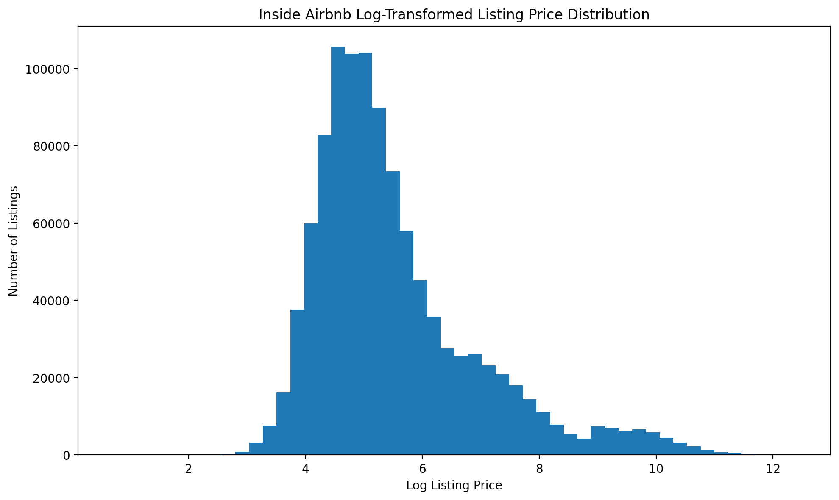
Figure 1. Distribution of log-transformed Airbnb nightly prices. Raw prices were extremely right-skewed (skewness 12.21); the log transform (skewness 1.36) gives a workable, near-normal shape. This is why we used median-based lodging costs and log/PCA treatment for cost features.
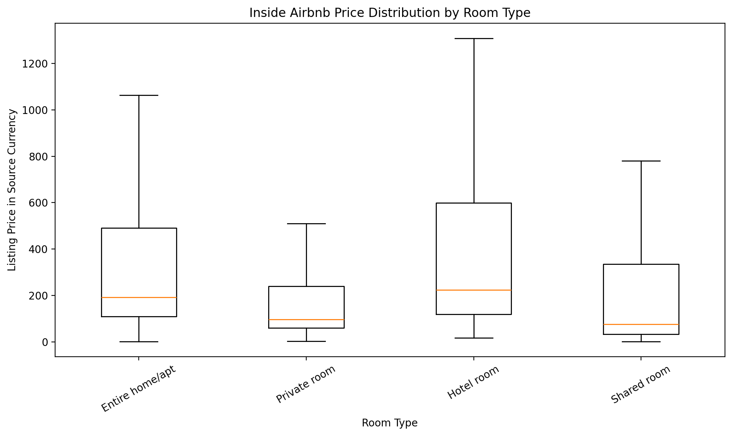
Figure 2. Nightly price by room type (box plot). Entire homes cost clearly more, and hotel rooms show the widest spread. This supports room type as a meaningful grouping variable.
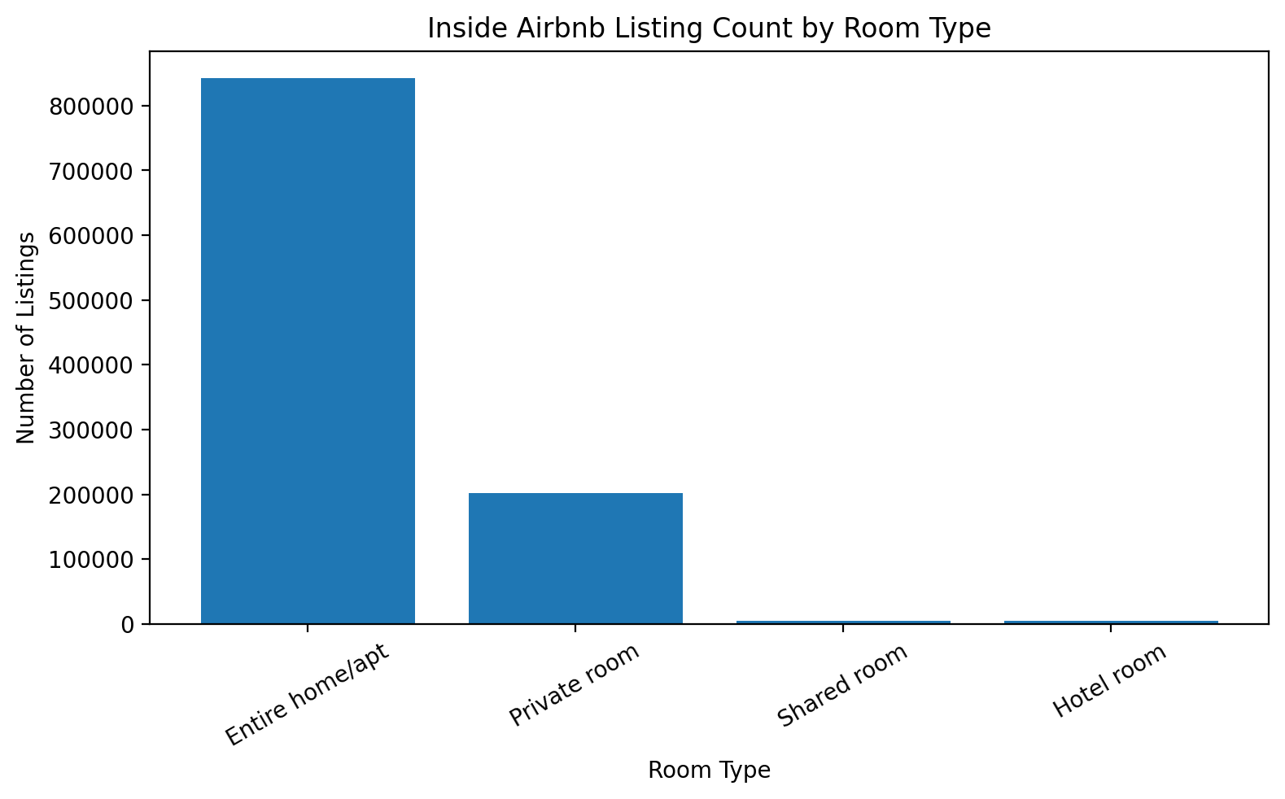
Figure 3. Room-type distribution. Entire home/apartment makes up 79.9% of listings. This imbalance would bias any listing-level classifier, so we aggregated to the destination level instead.
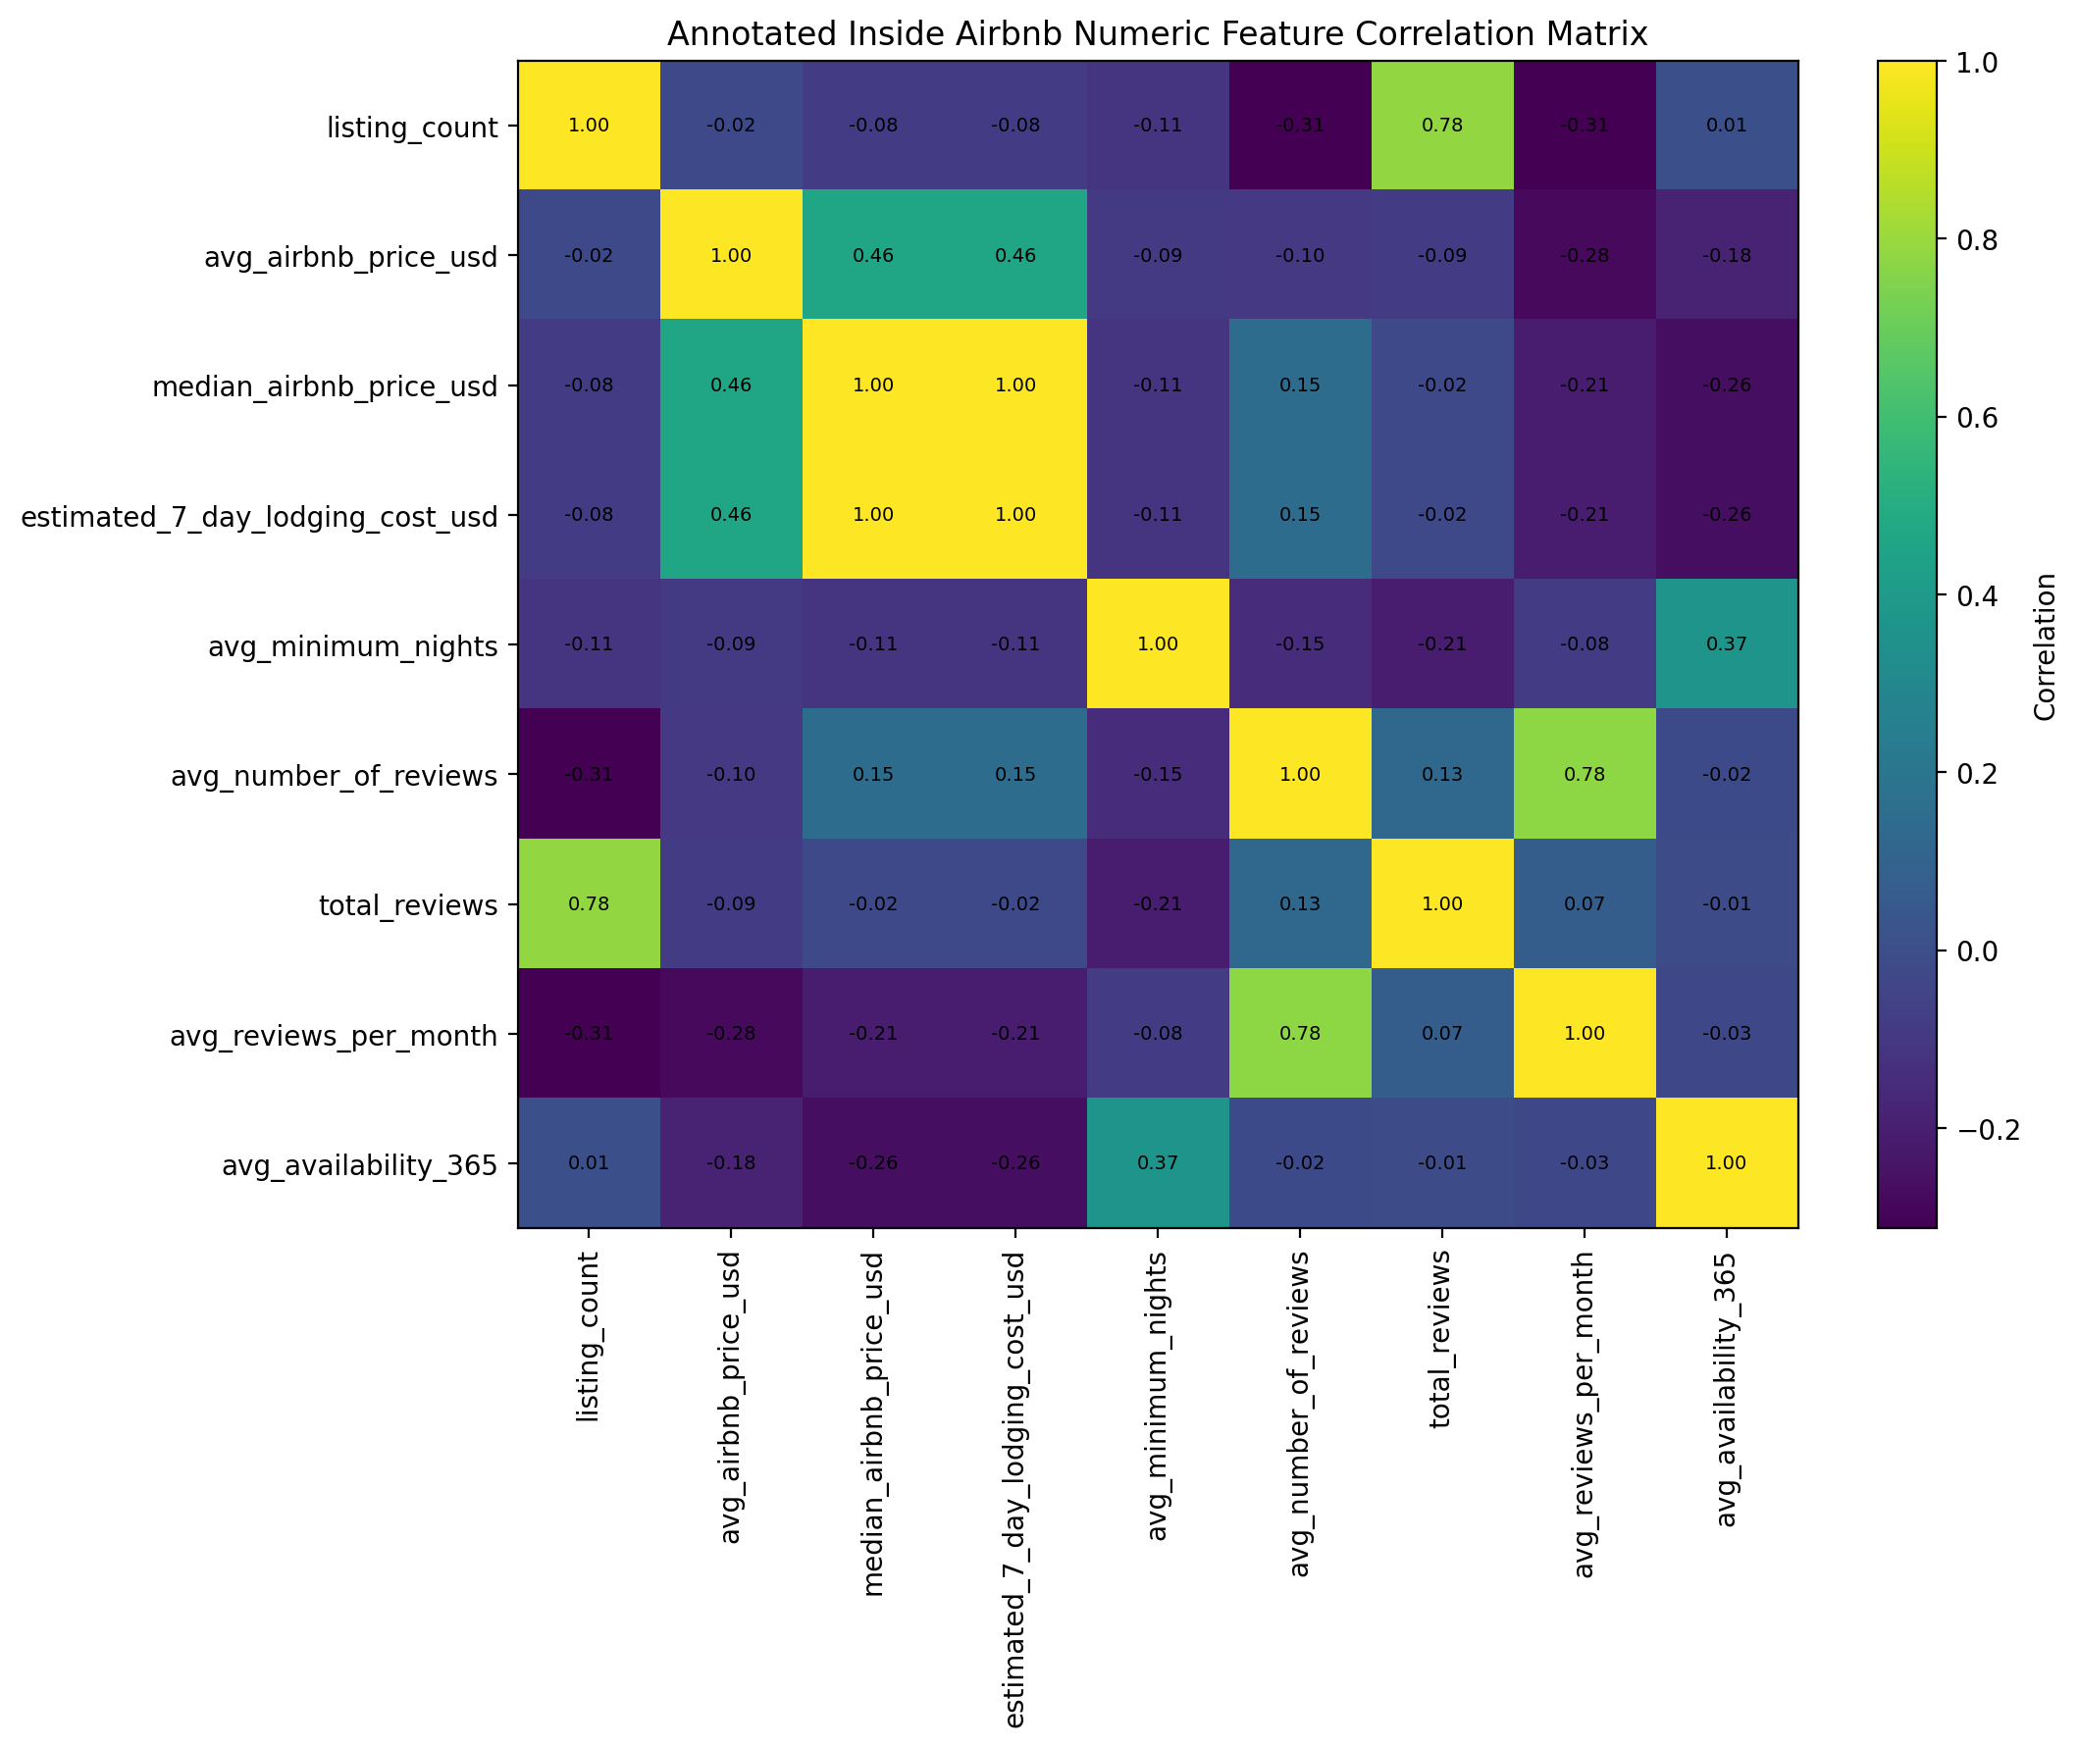
Figure 4. Correlation heatmap for the Airbnb block. The 7-day lodging cost and the median nightly price correlate at r = 1.00 by construction, and listing count correlates with total reviews at 0.785. Both findings drove the correlation-pruning stage of feature selection.
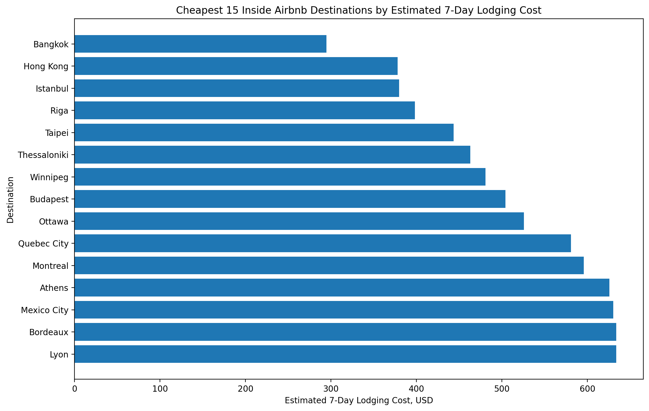
Figure 5. Sample visualization: the 15 cheapest destinations by median USD lodging cost. We inspected samples like these throughout EDA to sanity-check currency conversion and outlier handling.
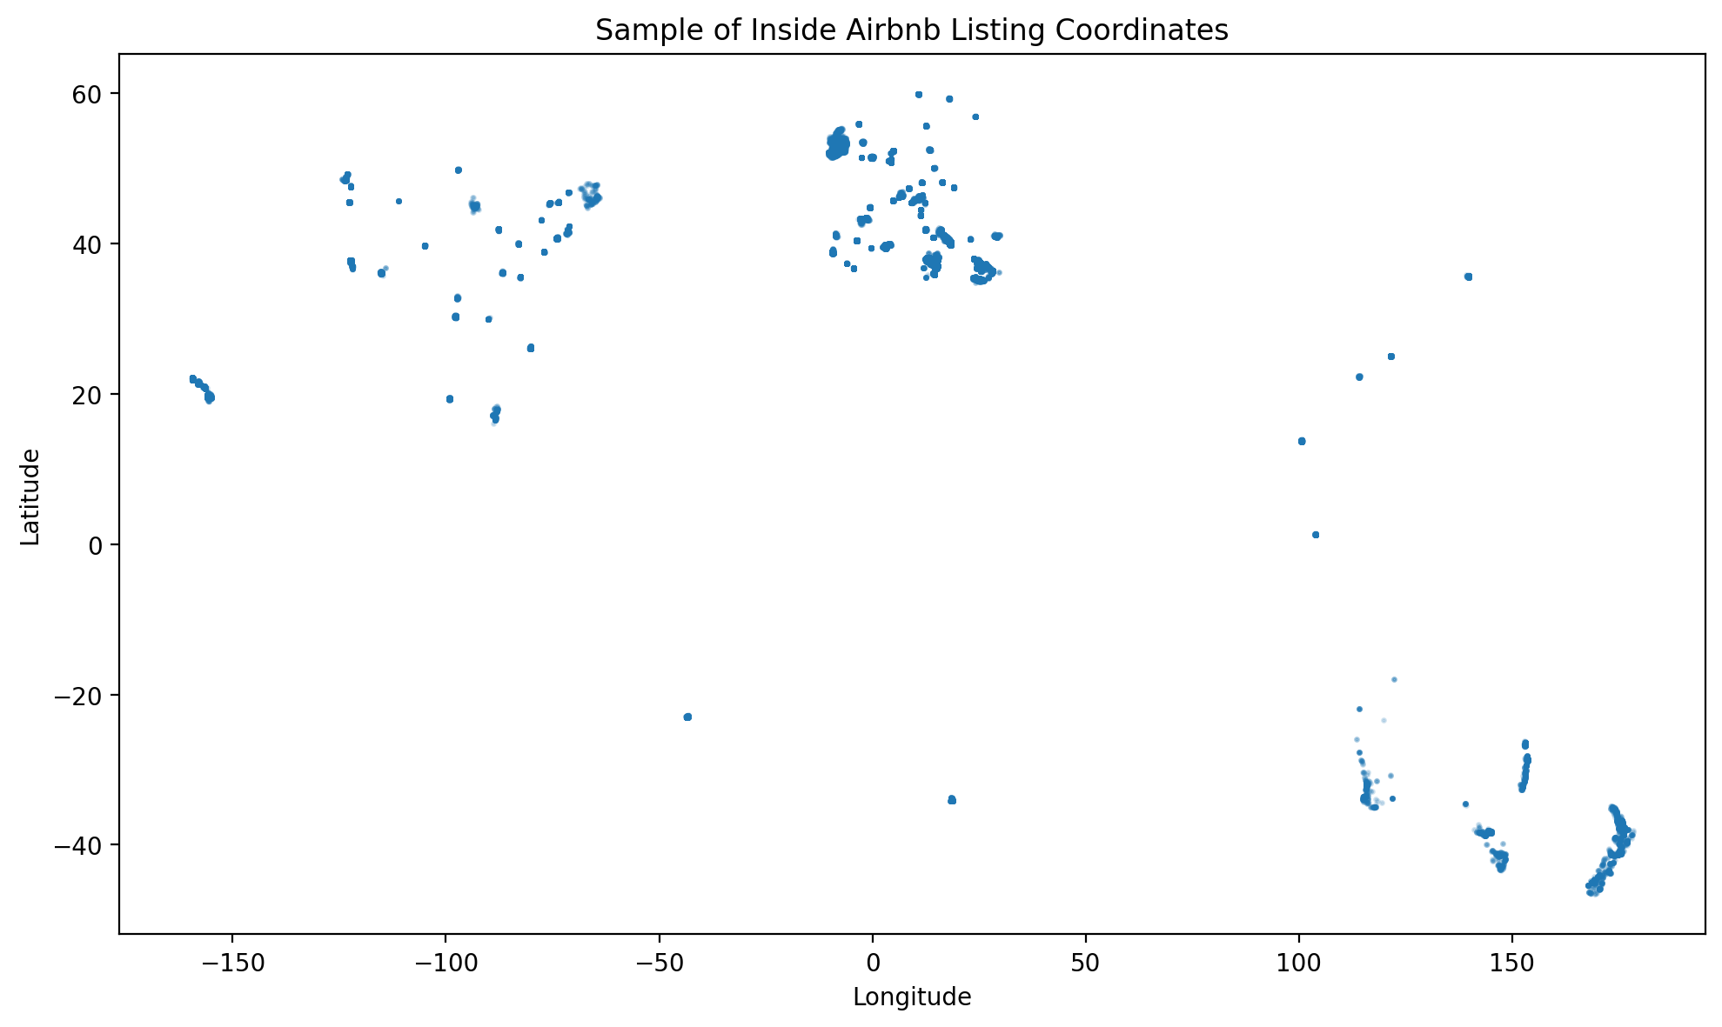
Figure 6. A sample of listing coordinates on the map, confirming the global coverage of the Airbnb extract and the quality of the coordinates used later for the distance-from-LAX feature.
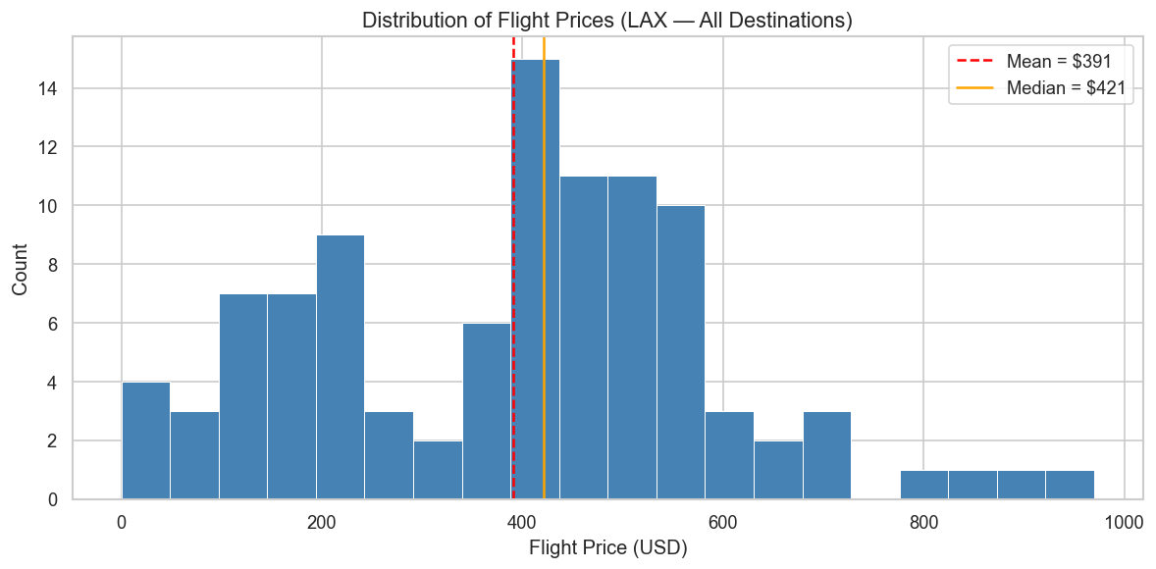
Figure 7. Distribution of LAX round-trip fares across the 49 quoted destinations and two seasonal windows. Most fares fall in the $200–$600 band with a long right tail, which later matched our Budget / Mid-range / Premium fare tiers.
Other key EDA findings: the World Bank tourism numbers are highly right-skewed (a few countries dominate global arrivals); weather scores show clear seasonality and class imbalance across cities; the TripAdvisor sub-ratings are strongly correlated with each other (later confirmed by the review PCA); and chi-square tests showed dependence between service and overall ratings. The exploration phase concluded that the sources must be merged onto one shared destination spine, and that a sentiment model was needed to create the missing destination-level satisfaction score.

3.3 Data Preprocessing Pipeline
Preprocessing ran in two phases: cleaning, transformation, and integration (Part 1), then feature engineering, selection, and extraction (Part 2). Every step below is implemented in notebooks 6 and 7 and is reproducible end to end.

3.3.1 Cleaning
- Missing values: profiled per source. We dropped rows only when a value could not be trusted (for example, a missing exchange rate); otherwise we kept and flagged them.
- Duplicates: exact duplicates and key-level duplicates were removed from every source.
- Outliers: 1.5×IQR capping on every numeric column, so extreme values are pulled to the boundary and no row is lost.
- Text standardization: whitespace and casing normalized on all city, country, and region fields.
- TripAdvisor special handling: cp1252 encoding with byte replacement, skipping malformed rows, cleaning city labels, forcing rating columns to numbers, and clipping ratings to the valid 1–5 range.

3.3.2 Transformation
- Aggregation: weather (city-month to city), flights (quote to destination), and TripAdvisor (review to city) were rolled up so every table shares one row per destination.
- Renaming: the cryptic Numbeo codes (x1 to x55) were renamed to readable labels, for example “cost of an inexpensive restaurant meal.” We also built four readable sub-indices (dining out, groceries, transport, housing) plus one cost-of-living composite.
- Encoding: six 0/1 coverage flags recording which sources each destination has; the missing subregion labels filled with an explicit “Unknown” category; and a rule-based climate zone category.
- Normalization: min-max scaling (for the weighted value score) and z-score standardization (for distance-based algorithms) computed alongside the raw columns, and StandardScaler applied before clustering and PCA. Reason: the sources mix scales from 0–1 indices to multi-billion-dollar receipts, so distance-based models would otherwise be dominated by the largest column.
- Discretization: a cost-of-living tier (Low / Medium / High by percentile thirds, 1,652 destinations each) and a flight-price tier (Budget up to $400 / Mid-range $400–800 / Premium above $800, which gave 20 / 28 / 1).

3.3.3 Integration
A key-building function created standardized join keys (strip artifacts, lowercase, remove punctuation, collapse spaces), and alias tables mapped known variants (“the netherlands” to “netherlands,” “new york” to “new york city”). We built a union destination spine of 4,999 unique destinations from the cost-of-living, flights, and Airbnb keys, then left-joined each cleaned source onto it (cost and Airbnb on the city+country key, weather and TripAdvisor on the city key, World Bank on the country key) so no destination is lost. Redundant per-source city and country text columns were dropped before each join. The result: the full integrated table (4,999 × 65 columns, later 94 with the Part 2 features) and a 49-row modeling-candidate subset of flight-quoted destinations.

3.3.4 Feature creation and target engineering
New feature | Method | Purpose
Latitude, longitude | Offline geocoding with the geonamescache library; 88.3% of the 4,999 cities matched | Coordinates for distance calculation
Distance from LAX (km) | Haversine formula against LAX (33.9N, 118.4W) | Input to the flight-price estimate
Filled flight price (USD) | Log-linear regression of fare on distance, trained on the 49 real quotes and LOO-validated (about $81 average error at this stage) | Fills missing fares so every city can be scored
Estimate flag | Binary: 1 = model estimate, 0 = real quote | Transparency, so estimates are never read as real quotes
Climate zone | Rule on absolute latitude: tropical / subtropical / temperate / polar | Simple climate category
We engineered two targets and kept them out of the input features to prevent leakage. The Budget Value Index (BVI) is a weighted average of scaled components: affordability (one minus the scaled cost), weather quality (scaled weather score), and traveler satisfaction (scaled, median-filled). It is computed only over the 105-city ranking pool that has both real cost and weather data. The binary budget-friendly label marks the top third of index scores (35 cities). At this stage the weights were Cost 40% / Weather 40% / Satisfaction 20%; in the final modeling run we refined them to 45/45/10 because only 20 of the 105 pool cities have review coverage (Section 4.3).
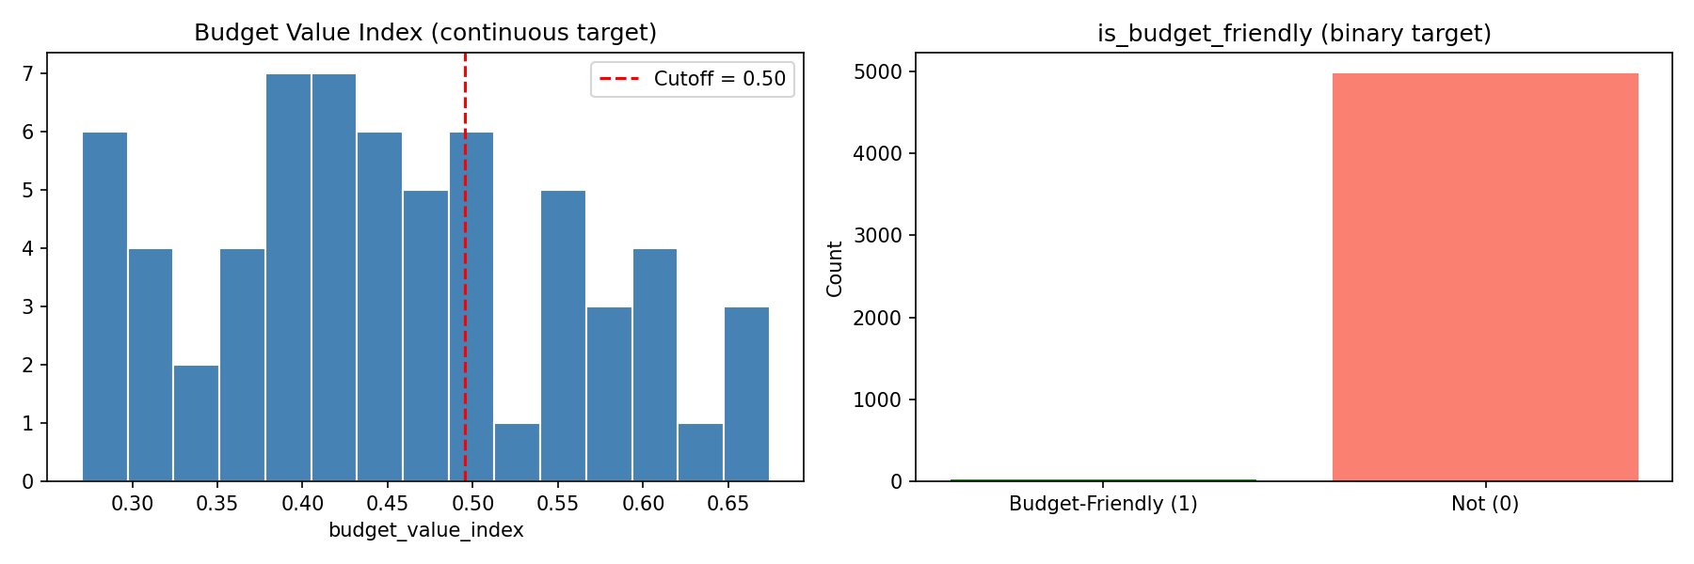
Figure 8. Distribution of the engineered budget value index across the ranking pool, with the top-third cutoff that defines the binary budget-friendly label.

3.3.5 Feature selection
Starting from 47 numeric and Boolean candidates (after removing IDs, label columns, and leakage columns), we applied three stages. First, a variance threshold of 0.01 on standardized features dropped nothing; all features carry real variation. Second, correlation pruning at |r| above 0.85 removed 17 redundant columns (scaled duplicates first, then raw line items in favor of composites; for example, the 7-day lodging cost was identical to the median nightly price at r = 1.00). Third, Random Forest importance: we trained a regressor on the continuous index and a classifier on the binary label (400 trees, max depth 6, min leaf 3, seed 42, using the 105 labeled pool cities), averaged the importances, and selected the top 12.
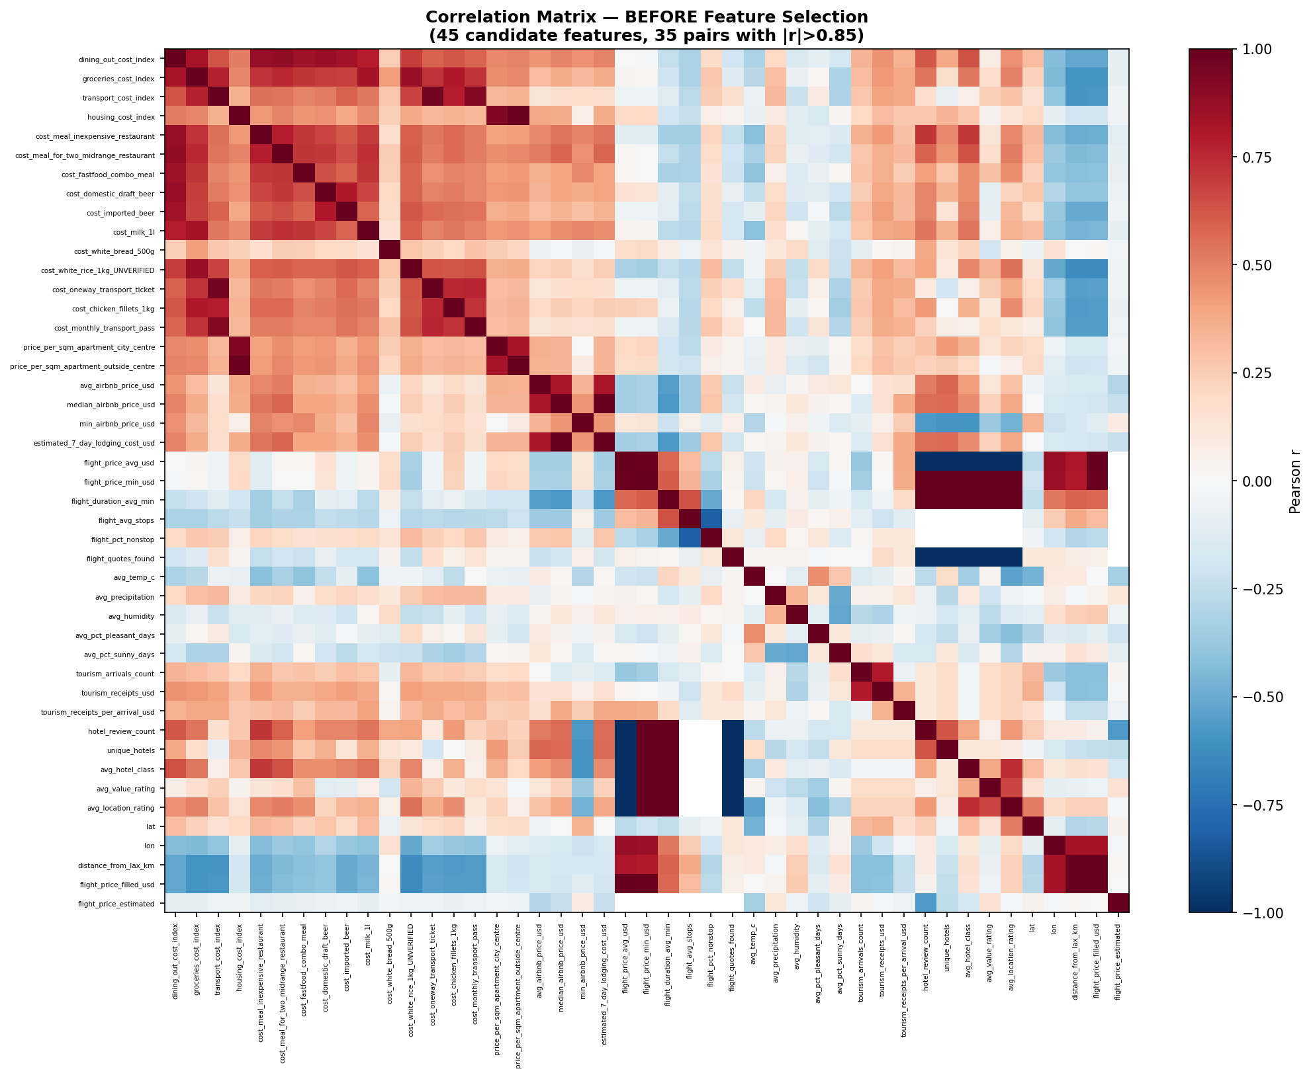
Figure 9. Correlation matrix before pruning: dense blocks of near-duplicate cost and flight features (|r| up to 1.00) justify pruning and PCA.
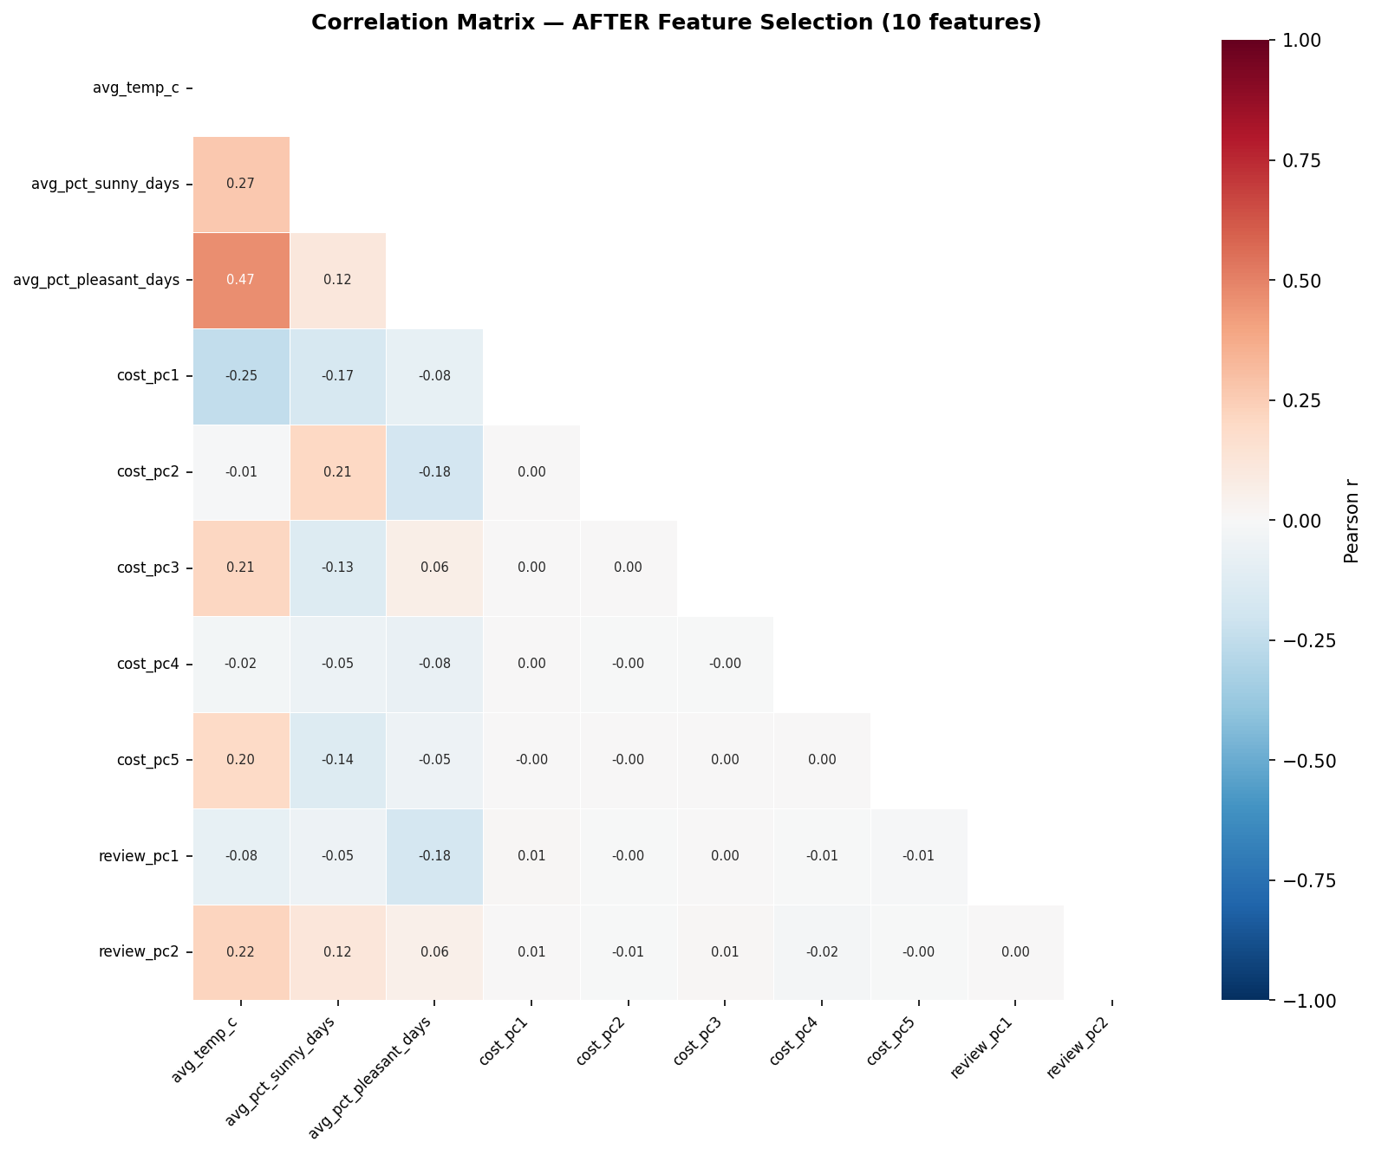
Figure 10. Correlation matrix after selection and PCA: the 10 final model features are nearly uncorrelated. The mild link between temperature and sunny days is expected, since warmer climates are sunnier.
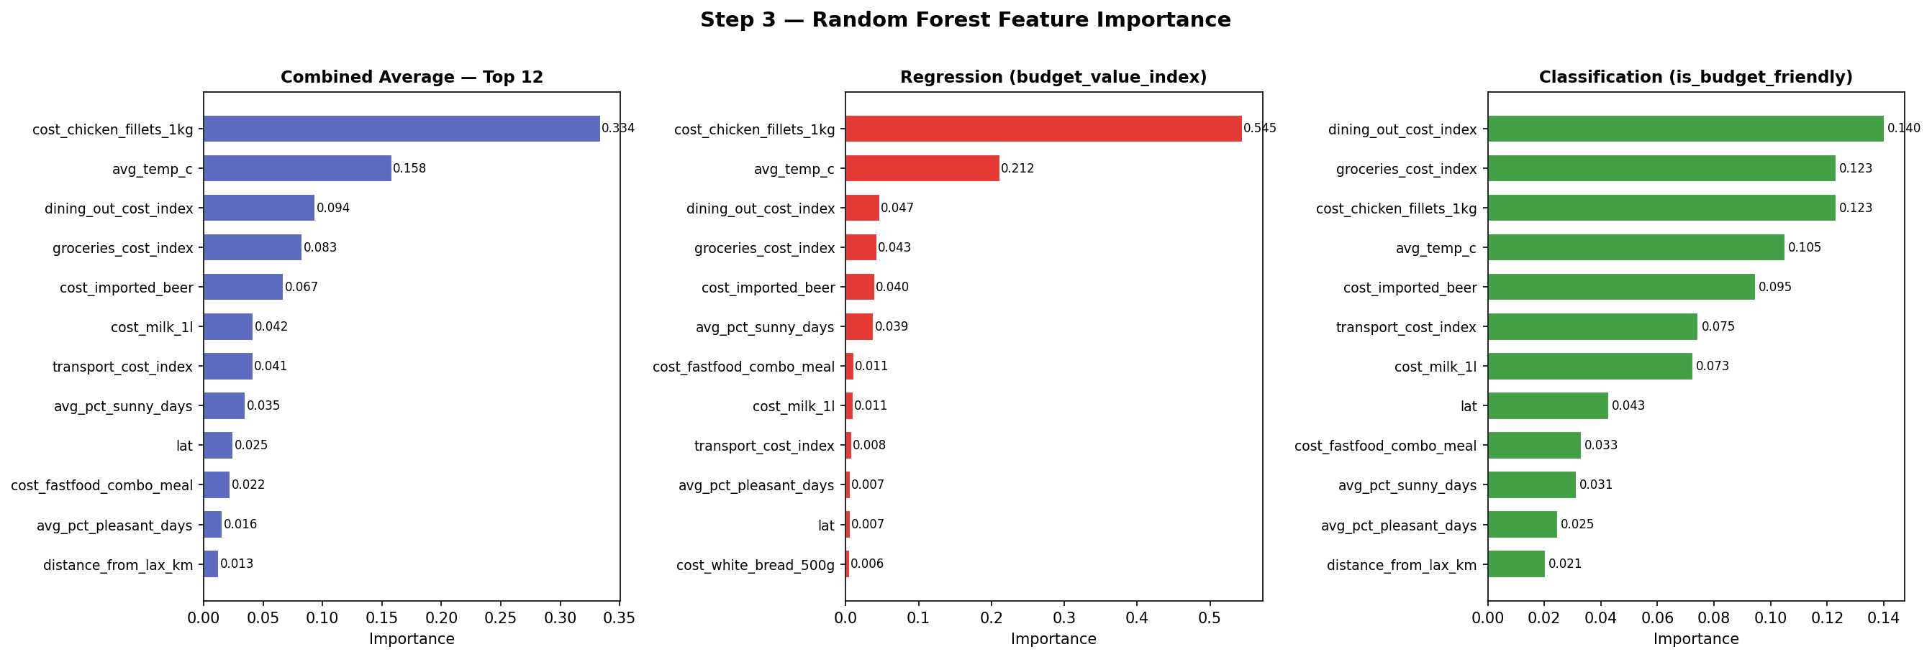
Figure 11. Random Forest combined feature importance. The chicken-fillet price item (0.339) and average temperature (0.164) lead. Seven of the top 12 belong to the cost block and were compressed by PCA instead of kept one by one.

3.3.6 Feature extraction (PCA)
We compressed two correlated blocks with PCA, after a log transform (to reduce right skew) and standard scaling (PCA is scale-sensitive). The 17-column cost-of-living block needed 5 components to reach 85% explained variance; the first component reflects the overall price level, and the later ones contrast cost categories such as housing versus dining. The 4-column hotel-review block needed 2 components; the first reflects overall guest satisfaction and the second the trade-off between value and location scores.

Figure 12. Cost-of-living PCA: cumulative explained variance. Five components reach the 85% threshold.
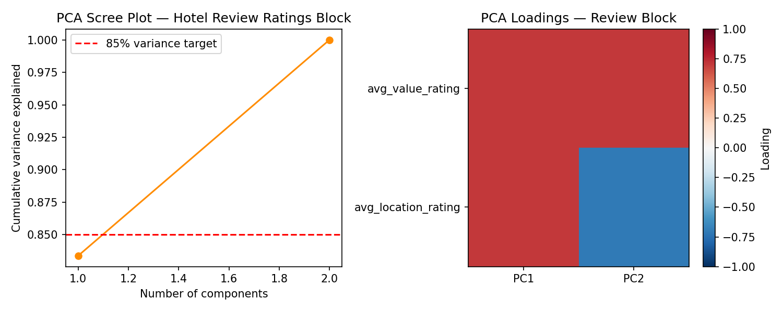
Figure 13. Hotel-review PCA: two components capture over 85% of the variance in the four correlated sub-ratings.

3.3.7 Train/validation/test methodology
Our core models are unsupervised (clustering and a composite ranking), and the one supervised model has only 49 labeled fare examples, so a standard 70/15/15 split would not be meaningful. Instead we matched the method to each model: Leave-One-Out cross-validation for the airfare model (every quote serves as a held-out test case exactly once, so the reported $59 average error is fully out-of-sample); five-seed stability tests plus cross-algorithm agreement for clustering; and weight-perturbation sensitivity analysis for the ranking. No held-out information was used for model selection. The evaluation protocols are detailed in Section 5.1.

Section 4 Model Selection, Architecture, and Training

4.1 Model Selection and Justification
We deliberately combined several algorithm families, which also satisfies the course requirement of at least two algorithms: unsupervised clustering, supervised regression, an NLP sentiment model, and a deterministic scoring model.
Model | Task | Why it fits | Strengths / limitations
K-Means (primary segmentation) | Cluster the 105-city pool on standardized cost, weather, distance, and fare | Clear, efficient centroid segmentation that matches the value-tier goal in our proposal | Fast, reproducible, easy to explain / assumes round clusters, sensitive to k and scaling
Agglomerative (Ward) | Hierarchical cross-check of K-Means | A non-centroid view; the dendrogram shows how destinations nest together | No upfront k assumption, deterministic / slower (O(n²))
DBSCAN | Density check and outlier detection | Finds dense groups of any shape and flags isolated cities | Great outlier detection / very sensitive to the eps setting; weak on diffuse data
Airfare regressor (Linear, Polynomial, Random Forest) | Predict missing LAX fares from geography | Fares grow non-linearly with distance; a Random Forest captures this without heavy tuning | Flexible and robust / only 49 training quotes, so estimates must be flagged
VADER sentiment (DistilBERT option) | Score about 879k reviews into a destination satisfaction score | Pre-trained lexicon model, runs on any CPU, no GPU needed; checked against star ratings (r = 0.96) | No training cost / less nuanced than a fine-tuned Transformer
Budget Value Index (BVI) | Composite ranking | Directly expresses the business objective as a transparent weighted score | Fully interpretable and tunable / the weights are judgment calls, so we tested them with a sensitivity analysis
We implemented real baselines, not just discussed them. The airfare Random Forest was compared against a mean-fare baseline and two simpler models (a log-log linear regression and a degree-2 polynomial). K-Means was cross-checked against Agglomerative and DBSCAN. The index ranking was compared against ablated versions of itself. The hyperparameters we tuned, and how, are documented in Section 4.5.

4.2 Architecture Description
- K-Means: input is a 4-dimensional standardized matrix (cost composite, weather score, distance from LAX, filled fare); 2 clusters; 10 restarts; seed 42.
- Agglomerative: Ward linkage, 2 clusters (matched to K-Means for a direct comparison), with the full dendrogram inspected in SciPy.
- DBSCAN: eps 0.5 and minimum 4 samples per core point, on the same standardized matrix.
- Airfare Random Forest (champion): 200 trees, maximum depth 4 (to avoid overfitting 49 examples), seed 42. Features: distance from LAX, latitude, and longitude. Target: round-trip fare in USD.
- Sentiment engine: VADER (NLTK) polarity scoring per review. The large review file is streamed in chunks with a per-city cap to keep compute bounded; compound scores are averaged per city and rescaled to a 0–1 satisfaction score. A swappable DistilBERT function (a pre-trained Transformer fine-tuned for sentiment) runs unchanged on Colab GPU; its self-attention handles negation and mixed opinions well. We used VADER for the final run because it is reproducible on any CPU.
- BVI scoring model: a deterministic formula: BVI = 0.45 × (1 − scaled cost) + 0.45 × scaled weather + 0.10 × scaled satisfaction, computed over the 105-city pool, with the min-max boundaries saved so new cities can be scored later.
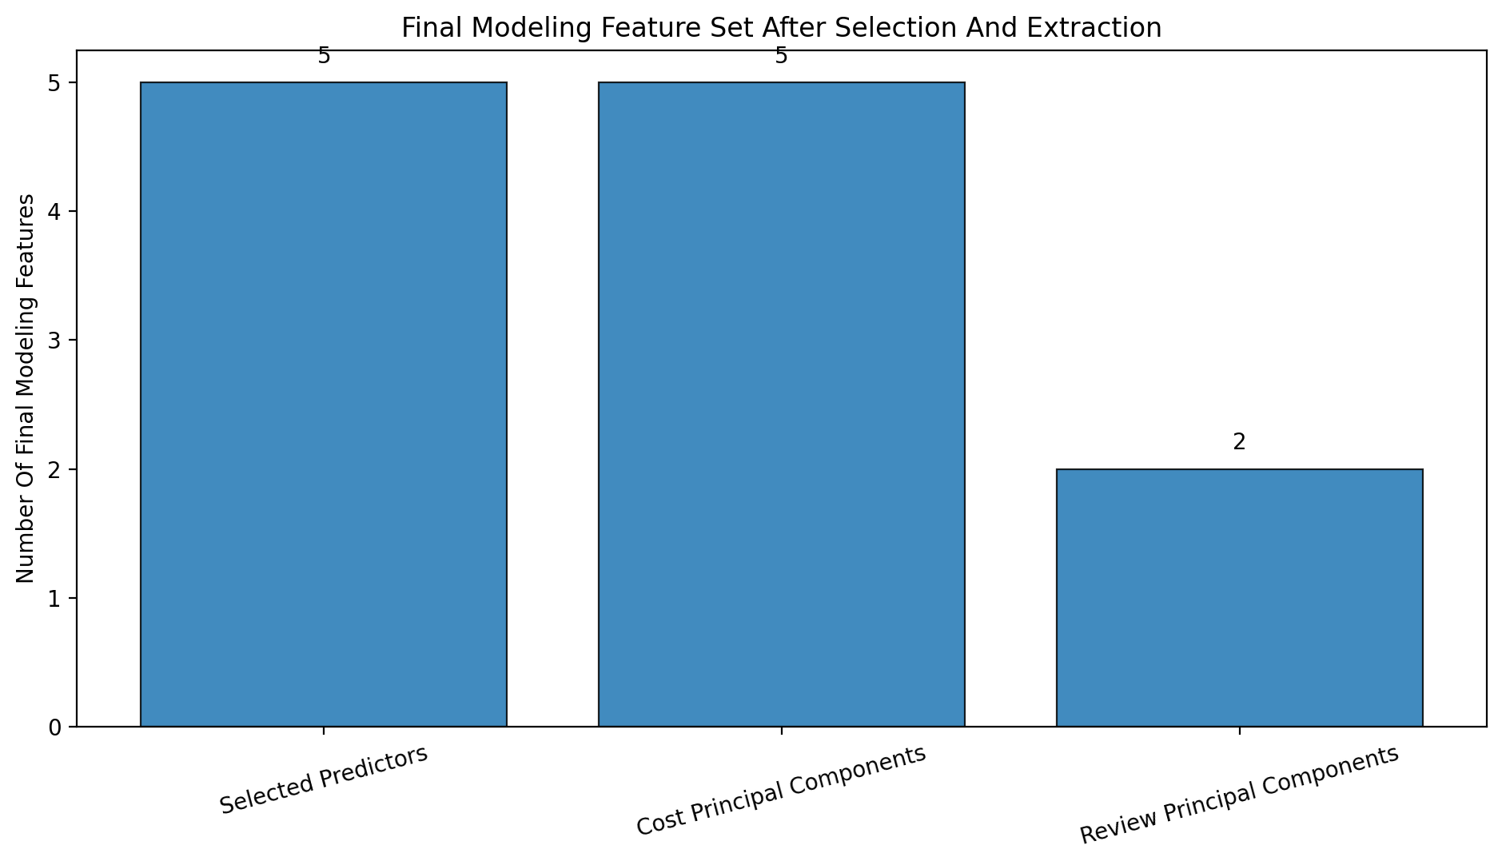
Figure 14. The final modeling feature set that feeds the clustering, regression, and BVI models.

4.3 Training Configuration
Component | What we used
Loss / objective | K-Means: within-cluster sum of squares. Agglomerative: Ward variance minimization. Random Forest: mean squared error splits, judged by mean absolute error. BVI: deterministic formula, no loss.
Optimization | K-Means: Lloyd's algorithm with 10 restarts. Random Forest: bagging of 200 trees. No gradient training was needed in the final pipeline, since VADER is pre-trained.
Hyperparameter sweeps | k from 2 to 8 for K-Means; eps from 0.50 to 2.50 in steps of 0.25 for DBSCAN; three airfare model variants ranked by LOO error.
Regularization | Random Forest depth and leaf-size limits to protect the small 49-quote sample; IQR capping upstream; PCA decorrelation of the inputs.
Batch size / streaming | Review scoring streamed in chunks (the file is 846 MB) with a per-city cap; every other model trains in memory.
Hardware | CPU laptops and free-tier Google Colab; the whole pipeline runs in minutes, and no GPU was required for the final run.
Reproducibility | A global seed of 42; clustering re-run across seeds 0, 1, 2, 42, and 100; automatic path resolution so the notebooks run locally or on Colab without edits.
Checkpointing / artifacts | Deterministic outputs saved at each stage: the satisfaction file, the model-ready dataset, the cluster profiles, the model assessment table, and the final rankings file.

4.4 Baseline Models
Three implemented baselines anchor the evaluation. First, a mean-fare baseline: predicting every fare as the training mean gives a $161 average error under LOO, while the champion Random Forest cuts this to $59. Second, the log-log linear regression and the degree-2 polynomial: simpler supervised baselines evaluated with the identical LOO protocol and metric; the Random Forest beat both. Third, for segmentation, Agglomerative clustering serves as the structural baseline for K-Means (they agree at ARI 0.82), and DBSCAN provides a density-based sanity check. All baselines were evaluated on the same data with the same metrics as the selected models.

4.5 Hyperparameter Tuning
We used exhaustive grid sweeps over small, justified ranges, which is appropriate for a compact 105-city pool. Model choice was driven by the silhouette score for clustering and LOO error for regression.
Model | Search space | Selection criterion | Final configuration
K-Means | k = 2, 3, 4, 5, 6, 7, 8 | Highest silhouette; the elbow curve as a sanity check | k = 2 (silhouette 0.413)
DBSCAN | eps from 0.50 to 2.50 in steps of 0.25; minimum samples fixed at 4 | Best silhouette over the non-noise points | eps = 0.5 (silhouette 0.457 on non-noise)
Airfare model | Log-log linear; polynomial degree 2; Random Forest (200 trees, depth 4) | Lowest LOO average error against the $161 baseline | Random Forest, $59 average error
BVI weights | Proposal weights 40/40/20; final 45/45/10; ablation variants | Domain reasoning plus Spearman rank stability | Cost 0.45 / Weather 0.45 / Satisfaction 0.10 (correlation 0.95 versus alternatives)
The computational cost of tuning was tiny; all sweeps finish in minutes on a CPU. We lowered the satisfaction weight from 20% to 10% because only 20 of the 105 pool cities have review coverage. This was a data-driven decision, and the sensitivity analysis in Section 5.4 confirmed it.

Section 5 Evaluation, Model Comparison, and Deployment

5.1 Evaluation Protocol
- Held-out integrity. The airfare model was evaluated with Leave-One-Out cross-validation: each of the 49 real quotes was predicted by a model trained on the other 48, so every reported error is out-of-sample, and no test information influenced model selection. The two engineered targets were kept out of all input feature matrices, and the columns used to build the targets were removed from the candidate features.
- Multi-seed stability. Clustering was re-run across five random seeds (0, 1, 2, 42, 100). Assignment variance stayed below the 0.02 threshold, so the segments are robust to initialization.
- Cross-algorithm agreement. A paired t-test does not apply to unsupervised partitions, so we quantified agreement between K-Means and Agglomerative with the Adjusted Rand Index (0.82), which corrects for chance. This is strong evidence the segmentation reflects real structure, not an algorithm artifact.
- Ranking robustness. The index was validated with Spearman rank correlation across alternative weight sets and feature-ablation runs (0.95), plus a top-10 overlap test.
- Sentiment validity. The destination sentiment scores were cross-checked against independent star ratings (correlation 0.96).

5.2 Performance Metrics
Following the course metric guidance, we report more than three metrics from the right families: clustering metrics (silhouette, Davies-Bouldin, Adjusted Rand Index), a regression metric (LOO mean absolute error against a baseline), and rank metrics (Spearman correlation):
Metric | Model(s) | Result | What it means
Silhouette score | K-Means / Agglomerative / DBSCAN | 0.413 / 0.386 / 0.457 (non-noise) | Moderate separation; the structure is real but soft
Davies-Bouldin index | K-Means / Agglomerative | 1.00 / 1.03 | Lower is better; K-Means edges out Agglomerative
Adjusted Rand Index | K-Means vs. Agglomerative | 0.82 | High agreement between the two methods, corrected for chance
LOO mean absolute error | Airfare Random Forest vs. mean baseline | $59 vs. $161 | 63% error reduction; fares are largely predictable from geography
Spearman correlation | BVI weight sensitivity | 0.95 | The ranking order barely moves under reasonable weight changes
Pearson correlation | Sentiment vs. star ratings | 0.96 | Text sentiment captures real satisfaction

5.3 Model Comparison
Model | Type | Performance | Efficiency | Generality / interpretability
A — K-Means | Clustering | Silhouette 0.413, DB 1.00 | Fast, O(nk) | Sensitive to k but stable across seeds; clear centroid personas
B — Agglomerative | Clustering | Silhouette 0.386, DB 1.03 | Slower, O(n²) | Agrees with K-Means (ARI 0.82); readable dendrogram
B2 — DBSCAN | Clustering | Silhouette 0.457; 7 clusters + 62 noise | Fast | Sensitive to eps; best used as an outlier flagger
C — Random Forest airfare model | Regression | LOO error $59 (baseline $161) | Instant inference | Small sample (49); all estimates flagged
BVI score | Ranking | Spearman 0.95 (weight-robust) | Instant, sub-second | Fully transparent and tunable
On complexity and speed: every final model is lightweight. There is no deep network in the final run, model files are tiny, and scoring takes under a second, so the performance-versus-cost trade-off favors the simplest adequate models. DBSCAN's higher raw silhouette applies only to the 43 non-noise cities; it labeled 62 of 105 cities as noise, so we kept it as an outlier detector rather than the main segmentation. Training-curve overlays do not apply to these closed-form and tree models; the tuning sweeps in Section 4.5 (the k sweep, the eps sweep, and the LOO comparison) play the same diagnostic role.
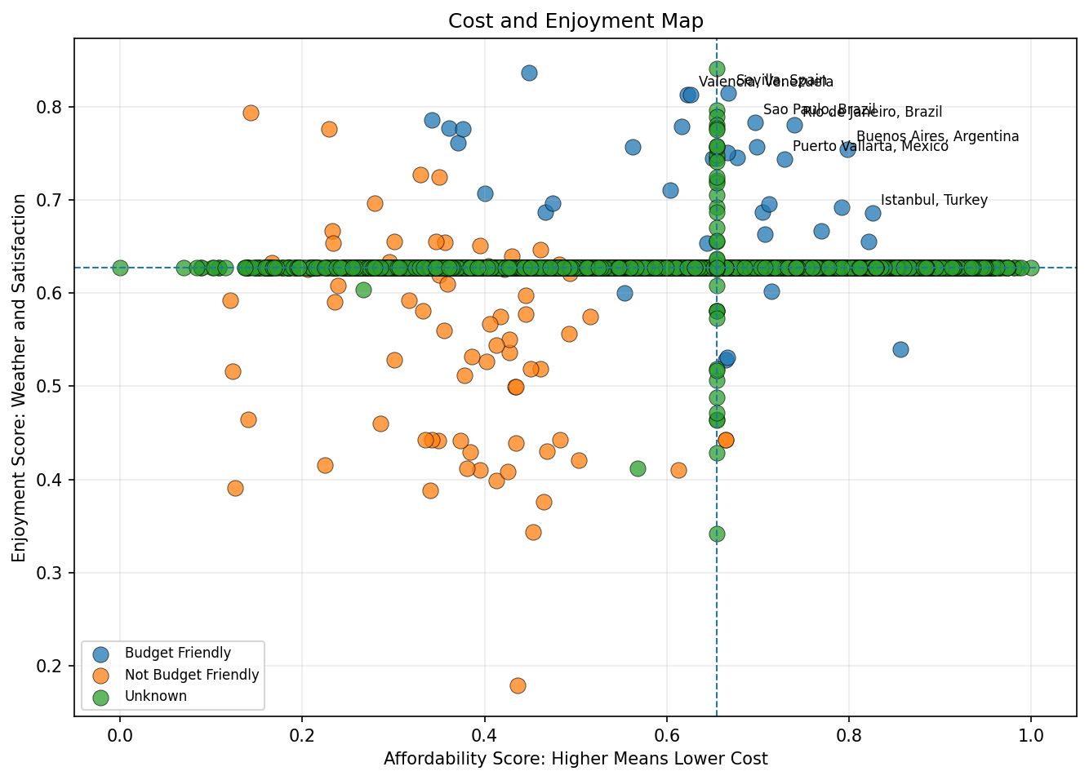
Figure 15. Cost versus enjoyment map of the destination pool. This is the visual heart of the comparison: the best budget destinations sit in the low-cost, high-experience corner.

5.4 Ablation Study
We ran two ablations on the BVI scoring model (the deployed model), plus one on the clustering features:
Ablation | What was removed or changed | Effect | What it shows
Satisfaction dropout | Remove the satisfaction component (weights become cost and weather only) | Spearman about 0.95 versus the full model; top-10 overlap stays high | The ranking is driven mainly by cost and weather; sentiment refines it rather than disrupts it, which fits the fact that only 20 of 105 cities have review data
Weight perturbation | Alternative weight sets around 45/45/10, including the proposal's 40/40/20 | Rank order stays stable (0.95) | The index is not an artifact of one specific weight choice
Clustering feature dropout | Single-variable dropout, watched through silhouette changes | Distance and fare dominate the two-segment split | The pool naturally divides into “near, cheap-fare” and “long-haul, costly-fare” personas

5.5 Final Model Selection
Our priorities, in order: a stable, transparent, business-aligned ranking first; readable segmentation second; coverage expansion third. Minimum thresholds: clustering had to beat a no-structure explanation and be stable across seeds; the airfare model had to beat the mean baseline under LOO; the index had to survive the sensitivity analysis. DBSCAN was dropped as the primary segmentation (62 of 105 cities labeled noise), and the two linear airfare variants were dropped for higher LOO error.
The deployed model is the Budget Value Index scoring framework paired with the K-Means segment labels, supported by the Random Forest airfare estimator (with estimates flagged). Deployment constraints: everything runs CPU-only with sub-second scoring, and the only artifacts are a small Python function and the saved scaling boundaries. Known limitations: the ranking is LAX-centric; satisfaction coverage is thin outside U.S. cities; fare estimates cannot see airline competition or seasonality; and the NDCG@K and Precision@K targets from the proposal could not be computed without ground-truth user relevance labels, so the weight-sensitivity protocol replaced them (a documented deviation).
The result: a final ranking of 105 destinations (top five: Buenos Aires, Rio de Janeiro, Sevilla, São Paulo, Istanbul) with two clear K-Means personas — “near, cheap-fare” (47 cities, average fare about $147, average distance about 2,681 km) and “long-haul, costly-fare” (58 cities, average fare about $467, average distance about 9,774 km).

5.6 Error Analysis
We manually inspected the largest out-of-sample airfare errors and grouped them into three types: routes priced below the distance trend by heavy airline competition; routes priced above trend by monopoly or hub premiums; and holiday-window quotes that spike for reasons geography cannot see. These error types confirm the model's known blind spot: geography explains most, but not all, fare variation. That is exactly why every estimated fare carries an estimate flag. On the data side, we caught name collisions during integration (for example, Valencia and Barcelona in Spain versus their Venezuelan namesakes); these are logged as a monitored risk, and the duplicate-named cities appear separately and correctly in the final ranking. For clustering, the 62 DBSCAN noise cities show the pool is diffuse between the two macro-segments, which is a limitation of any hard partition of this data.

5.7 Deployment Plan
- Delivered artifacts (batch pipeline). The final rankings file (105 rows × 12 columns: rank, city, country, index score, segment persona, satisfaction, cost profile, weather score, distance, fare, estimate flag, climate zone), the cluster profiles file, the destination satisfaction file, and the model assessment table.
- Web dashboard. An interactive HTML dashboard visualizes the rankings and segments for non-technical users. This is the deployment demo the guideline encourages.
- On-demand scoring. A small, zero-dependency Python function takes a city's cost composite and weather score and returns a 0–1 value score using the saved scaling boundaries. It is the seed of a REST API; a FastAPI wrapper is the natural next step.
- Monitoring. Watch the airfare error as live fare data arrives (pricing drift); watch the saved min and max scaling values against inflation and climate shifts (re-baselining); and keep logging place-name collisions.
- Operational readiness. The deliverables exceed the 50-destination requirement (105), attach readable personas, and clearly flag every estimated fare.

Section 6 Summary of Learning Experiences

6.1 Experiments Conducted and Key Findings
- Six-source integration was the hardest and most valuable work. The same city can be spelled five ways, priced in four currencies, and reported at three geographic levels. The standardized-key and alias-table approach worked; joining on raw text would not have.
- What worked: capping outliers instead of dropping rows preserved our small destination pool; the coverage flags let a model tell “missing” apart from “zero”; PCA cleanly compressed 21 correlated columns into 7 components; and the distance-based fare estimator expanded coverage from 49 to 105 scored cities.
- What did not go as planned: the Numbeo direct download (premium-only) and the Amadeus flight API (deprecated tier) both forced source substitutions; about 61% of the raw TripAdvisor rows were unrecoverable because of malformed quoting; and DBSCAN turned out to be unsuitable as a primary segmenter for this diffuse pool.

6.2 Ablation Insights
The index ablations showed that the ranking is basically a cost-and-weather story. Removing the satisfaction component barely moves the order (correlation around 0.95). That surprised us at first, but it follows from coverage: with only 20 of the 105 pool cities carrying review data, sentiment can refine the ranking but cannot dominate it. The clustering ablation showed that distance and airfare, not ground cost, drive the top-level structure of the pool. For a traveler starting in Los Angeles, how far you fly is the first budget decision.

6.3 Lessons from Readings
CRISP-DM 1.0 (Chapman et al., 2000) shaped the whole project structure, especially its point that Modeling and Evaluation iterate. That is exactly what happened when integration exposed the flight-coverage gap. The VADER paper's design goal, a social-media-tuned lexicon that needs no training, is why it fit so well as the reproducible fallback to DistilBERT, and the DistilBERT paper (Sanh et al., 2019) informed our original Transformer plan. The scikit-learn documentation guided the silhouette-driven choice of k and the correct use of Leave-One-Out cross-validation for very small samples.

6.4 Challenges and Resolutions
Challenge | How we resolved it
An 846 MB review file, not valid UTF-8, with malformed rows | Chunked streaming with cp1252/latin-1 decoding, a per-city sampling cap, and skipping malformed rows
API rate limits (OpenWeatherMap, 50k records per day) | Batched collection across days, immediate caching of responses, and prioritizing the shared destination list
Same city name in different countries | Composite city+country keys and collision logging (the Valencia/Barcelona case)
No GPU for Transformer fine-tuning in the final run | The VADER lexicon engine on CPU, validated against star ratings (r = 0.96), with the DistilBERT path preserved
Only 49 real fare quotes | Distance-based estimation with LOO validation and mandatory estimate flags

6.5 Division of Labor
Angela Johnson and Annabel Tapia led the cost-of-living and World Bank tourism collection and cleaning. Josue Sanchez and Jeffrey Morales Toledo led the Inside Airbnb and Google Flights collection. Hasmik Galstyan and Thant Thiri Myo Kyi led the TripAdvisor reviews and OpenWeatherMap climate collection. Data preparation, integration, modeling, evaluation, the dashboard, and all reports were shared group work, and every member reviewed and revised the phase reports (see the revision histories in the phase documents).

6.6 What We Would Do Differently
- Lock the master destination list in week 1, before collecting from any source, so every collector targets the same cities from the start.
- Collect fares from two or three origin airports so the ranking is less LAX-centric.
- Sample international (non-U.S.) review sources early, so the satisfaction signal covers more of the pool.
- Budget Colab GPU time for a DistilBERT fine-tune, to compare it directly against VADER on this corpus.
- Automate data-quality checks (schema, encoding, currency) as tests, instead of discovering issues by hand in the middle of a phase.

Section 7 References
All references below are cited in the body text using [n] notation.
[1] AWeirdDev. (2024). fast-flights [Computer software]. GitHub. https://github.com/AWeirdDev/flights
[2] Chapman, P., Clinton, J., Kerber, R., Khabaza, T., Reinartz, T., Shearer, C., & Wirth, R. (2000). CRISP-DM 1.0: Step-by-step data mining guide. SPSS Inc.
[3] Piedade, M. (2023). Global Cost of Living [Data set]. Kaggle. https://www.kaggle.com/datasets/mvieira101/global-cost-of-living
[4] The World Bank. (2024). World Development Indicators — Tourism. DataBank. https://databank.worldbank.org/id/f1ddbc94
[5] Inside Airbnb. (2024). Get the Data. https://insideairbnb.com/
[6] Joe Beach Capital. (2023). Hotel Reviews [Data set]. Kaggle. https://www.kaggle.com/datasets/joebeachcapital/hotel-reviews
[7] Amadeus. (2024). Amadeus for Developers — Flight Offers Search API. https://developers.amadeus.com/
[8] OpenWeather. (2024). OpenWeatherMap History API. https://openweathermap.org/api
[9] Hutto, C. J., & Gilbert, E. (2014). VADER: A parsimonious rule-based model for sentiment analysis of social media text. Proceedings of the Eighth International AAAI Conference on Weblogs and Social Media (ICWSM-14). https://doi.org/10.1609/icwsm.v8i1.14550
[10] Sanh, V., Debut, L., Chaumond, J., & Wolf, T. (2019). DistilBERT, a distilled version of BERT: smaller, faster, cheaper and lighter. arXiv:1910.01108. https://arxiv.org/abs/1910.01108
[11] Pedregosa, F., et al. (2011). Scikit-learn: Machine learning in Python. Journal of Machine Learning Research, 12, 2825–2830. https://jmlr.org/papers/v12/pedregosa11a.html
[12] Ester, M., Kriegel, H.-P., Sander, J., & Xu, X. (1996). A density-based algorithm for discovering clusters in large spatial databases with noise. Proceedings of KDD-96, 226–231.
[13] MacQueen, J. (1967). Some methods for classification and analysis of multivariate observations. Proceedings of the Fifth Berkeley Symposium on Mathematical Statistics and Probability, 1, 281–297.
[14] Breiman, L. (2001). Random forests. Machine Learning, 45(1), 5–32. https://doi.org/10.1023/A:1010933404324

Section 8 Appendix

8.1 Source Code
All code is organized by CRISP-DM phase in the project folder COMP541_Reorganized and archived in the shared repository: CSUN COMP/BSYS 541 – Data Mining: Working Files — https://drive.google.com/drive/folders/1E2d_3uOsIVQDo3emrRN75QZBLABiLUIi (a GitHub mirror can be added at submission).
Notebook | Phase | Purpose
1–5 Data Collection, Cleaning & EDA (one per source) | Phases 1–2 | Per-source collection, cleaning, and EDA (cost of living and tourism, TripAdvisor, OpenWeather, Airbnb, flights)
6 Data Preprocessing Part 1 (Integration) | Phase 3 | Cleaning, transformation, and six-source integration into the full destination table
7 Data Preprocessing Part 2 (Feature Selection) | Phase 4 | Feature creation, index target, feature selection, and PCA into the model-ready dataset
8 Sentiment & Satisfaction | Phase 5 | VADER/DistilBERT sentiment over about 879k reviews into the destination satisfaction file
9 Data Modeling | Phase 5 | Clustering, airfare regression, the index, evaluation, and deployment artifacts

8.2 Sample Predictions — Final Top-10 Ranking
Rank | City | Country | BVI | Segment | Fare (USD) | Fare source
1 | Buenos Aires | Argentina | 0.875 | long-haul, costly-fare | 292.50 | Real quote
2 | Rio de Janeiro | Brazil | 0.863 | long-haul, costly-fare | 517.00 | Real quote
3 | Sevilla | Spain | 0.850 | long-haul, costly-fare | 443.82 | Estimated
4 | São Paulo | Brazil | 0.839 | long-haul, costly-fare | 365.00 | Real quote
5 | Istanbul | Turkey | 0.830 | long-haul, costly-fare | 582.50 | Real quote
6 | Puerto Vallarta | Mexico | 0.823 | near, cheap-fare | 134.50 | Real quote
6 | Valencia | Venezuela | 0.823 | long-haul, costly-fare | 292.25 | Estimated
8 | Valencia | Spain | 0.821 | long-haul, costly-fare | 452.25 | Estimated
9 | Barcelona | Venezuela | 0.817 | long-haul, costly-fare | 304.95 | Estimated
10 | San Juan | Argentina | 0.815 | long-haul, costly-fare | 424.39 | Estimated
Segment personas (from the cluster profiles file): Cluster 0, “long-haul, costly-fare” (58 cities; average distance 9,774 km; average fare $467), and Cluster 1, “near, cheap-fare” (47 cities; average distance 2,681 km; average fare $147). Both groups share similarly low ground costs and weather scores around 69 out of 100; the real split is the cost of getting there.

8.3 Additional Visualizations
The full chart inventory accompanies this report in the project folder: the Phase 1–2 EDA charts (30+ figures: histograms, KDE plots, box plots, correlation heatmaps, bar rankings, scatter and area plots for the Airbnb and flight data), the Phase 4 feature-selection charts (variance threshold, correlation before and after, Random Forest importance, PCA scree plots, target distribution, feature-decision summaries, cost-enjoyment map, cost-PCA space), and the Phase 5 final feature-set diagram plus the interactive dashboard.

8.4 Group Activity Documentation and Media
The deliverable package includes the project video, “Finding the Best Budget-Friendly Travel Destinations.mp4”, and the presentation deck (PDF with page numbers). Each phase report carries a revision history table that documents per-member contributions and group review sessions. Screenshots and captured images of group working sessions accompany the submission package.

8.5 Deviations from the Proposal (Transparency Log)
- Numbeo replaced by the Kaggle Global Cost of Living mirror (premium paywall).
- The Amadeus API replaced by the fast-flights Google Flights parser (the free tier was deprecated).
- The DistilBERT fine-tune replaced by the VADER lexicon engine for the final reproducible run, with the DistilBERT path implemented and swappable (validated against star ratings, r = 0.96).
- NDCG@K and Precision@K replaced by Spearman weight-sensitivity plus top-K overlap validation (no ground-truth relevance labels exist).
- The index weights moved from 40/40/20 to 45/45/10 (satisfaction down-weighted for coverage; justified and ablation-tested).

